Rapid HANA Assessment Instructions

This document describes the instruction to execute a rapid assessment for HANA.
The operation is performed on your HANA productive system, on DB level through SAP Hana Studio (or Eclipse) and the download of the 2 output files is done on your local computer, within seconds.
It consists of SELECT statements on metadata (catalog) only. There is no impact and no read on your master data, neither transactional data.

Pre requirements
- To have access to the HANA DB via SAP Hana Studio/Eclipse
- A valid HANA DB user with ADMIN privilege

Steps:
- From the folder shared get the 2 SQL Statement files:

  - “Hana_Modernization_Assessment_Tech_Info.txt” contains the code to extract some technical information on your HANA environment.
  - “Hana_Modernization_Assessment_Objs.txt” contains the code to extract the list of the available objects.
- Log in into your HANA DB Production System using the SAP Hana Studio (or Eclipse)
- Open the SQL console to be able to run the SQL code
- Copy, paste and execute the scripts defined in the files from the step1
- For each of these, from the result tab with the right click select “Export Results...” to download the extractions in CSV format. We expect the CSV file to use a semicolon (;) as the separator and to include the following details:
  - *Tech_Info.txt results should be named Assessment_Tech_Info.csv
  - *Objs.txt results should be named Assessment_Objs.csv
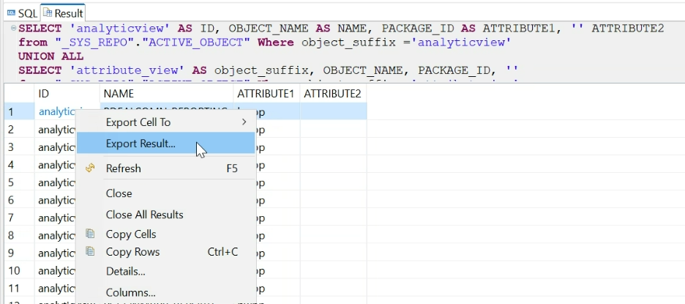
Point of attention: when executing the scripts, ensure to have not the limits set to 5,000 records, in order to avoid results truncation. For more information please consult the following SAP Note: https://me.sap.com/notes/0003224863
- Move the results files into a new folder and zip it into a folder named Input.zip.
- Send the file back to SAP.
Notes:
- In case you need any assistance don’t’ hesitate to contact us at adeem.zia.ul.haq@sap.com or giancarlo.colaci@sap.com

